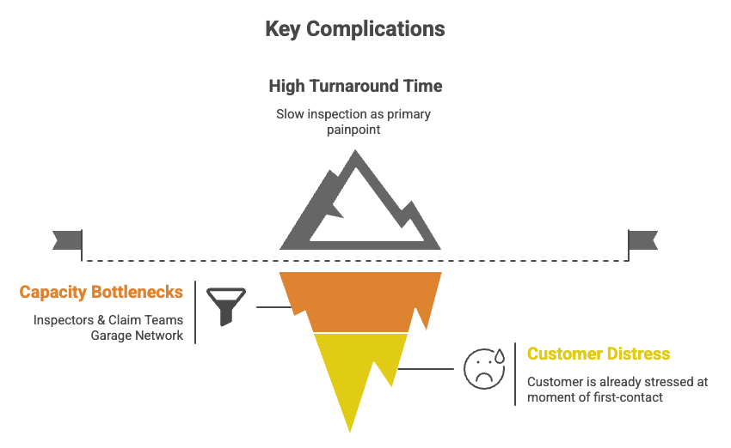
Situation: InsureApp uses a digital-first, app-based First Notice of Loss and handles all claims through a inspector-led process. Most delays come from inspector scheduling, manual review and settlement, giving a ~4.2-day TAT. 65% of all claims are minor (<₹25k), and early AI/self-inspection pilots show strong user uptake.

Complication: Customers are stressed at claim time, and long inspector wait times drive dissatisfaction. The current flow applies heavy, slow controls even to simple, repeatable minor claims. With InsureTech and market leaders pushing fast AI-led claims, InsureApp risks falling behind.

Key Question: How can InsureApp reduce the inspection TAT from 4.2 days to under 24 hours for at least 50% of claims within the next 6 months, while maintaining fraud detection capabilities & customer trust?

Part 1: Problem Analysis & Solution Design

A. Stakeholder & Constraint Analysis

1. Identify all key stakeholders affected by solving key complications

Stakeholders | Possible Benefits | Possible Pains / Risks
Customers | • Faster approvals (same-day)  • More independence regarding via self-inspection | • Anxiety if AI rejects or reduces payout without clear explanation  • Fear of “black-box” AI decisions  • Friction of capturing good photos (esp. at night)
Inspectors | • Focus on complex / high-risk cases where their expertise matters  • Less travel-heavy work on minor claims  • More predictable routing | • Perceived threat to role importance  • Being brought in only for the hardest borderline cases
Claims Operations Team | • Lower manual load on simple claims  • Fewer repetitive customer calls  • Clear routing criteria based on AI scores | • Need to learn new tools, thresholds, and routing logic  • Spike of escalations if customers distrust AI
Tech / AI Team | • Models actually used in production (not pilots)  • Opportunity to build scalable digital claims engine | • Pressure to meet unrealistic accuracy expectations  • Being blamed for decisions that are actually policy choices  • Data scarcity for certain damage types
InsureApp Leadership | • Ability to hit the 50% <24h TAT target  • Lower cost per minor claim  • Better NPS and competitive positioning vs InsureTech | • Investment in AI/ops redesign may not show immediate ROI  • Risk of customer backlash if AI explanations are weak  • Leakage/Fraud risk if controls are not calibrated well
Garages (Network & Non-Network) | • Faster work approvals  • Predictable, standardised rate cards  • Less back-and-forth with inspectors | • Confusion when AI cost-band differs from their estimate  • More documentation uploads from them if part of the digital flow
Competitor: InsureTech | • Forces higher bar for digital claims | • If InsureApp executes well, InsureTech becomes less attractive  • Their digital claims messaging becomes less differentiated
Regulators (IRDAI) | • Ability to show fairness & transparency in digital flows | • Need to ensure compliance with IRDAI expectations on fairness/timeliness

2. List the top 5 constraints you must consider

Constraints | Implication for <₹25k Minor-Claims Solution
1. Fraud & Leakage (Risk / Controls) | • Must embed fraud scoring, image-integrity checks, and rules-based controls in the digital flow.  • Require clear thresholds for auto-approve vs claims review vs inspector exception.  • Need auditability and explainability for AI decisions to satisfy compliance and customer trust.
2. AI & Data Maturity (Information / Technology) | • AI should act as triage + decision support, not full adjudication.  • Auto-approval restricted to high-confidence, low-risk cases.  • Human-in-the-loop needed for borderline or ambiguous minor claims.  • Continuous model training required using InsureApp’s growing image dataset.
3. Operational Capacity (Operations / People) | • Inspectors cannot remain the default step for <₹25k claims — they are the largest TAT bottleneck.  • Need to shift majority of minor claims into digital-first or hybrid flows.  • Claims team must focus on exceptions, not every simple case.  • Must redesign workloads, SLAs, and routing logic for surveyors and claims handlers.
4. Customer Behaviour & Trust (People / Customer) | • AI-driven decisions (especially rejections/partial approvals) must be clearly justified to avoid dissatisfaction.  • Journey must keep visible human escalation paths (chat/call/review).  • Needs guided capture + simple instructions to avoid rework and frustration.  • Must handle night-time / poor-lighting situations gracefully without compromising fraud control.

3. What success metrics would you track beyond TAT reduction?

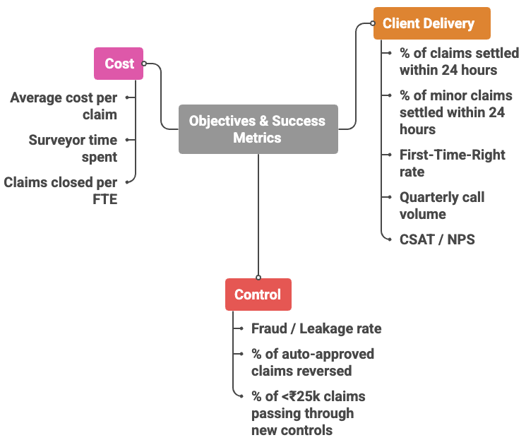
The metrics should be able to tell me if the solution is faster for customers, safe on risk, and sustainable on the P&L. Client Delivery captures what customers actually experience. First-Time-Right rate is a leading quality metric: if most claims are processed without rework, then data capture and rules are well designed and the TAT gains are structural. Quarterly call volume and CSAT / NPS at claim closure together test whether customers can self-serve, understand the decision (especially when AI reduces or denies a claim), and still trust the insurer. “% settled within 24 hours” metrics, at portfolio and <₹25k segment level, act as lagging outcome indicators of speed.

Control ensures speed is not bought at the cost of risk. Fraud / leakage rate for <₹25k claims tracks money lost to fraud and overpayment. The % of auto-approved claims later reversed or heavily adjusted is a direct quality check. % of <₹25k claims passing through the new controls (AI damage and fraud scoring, rules) measures the consistency and coverage of the redesigned control framework.

Cost tests scalability and sustainability. Average cost per <₹25k claim, surveyor time allocation between minor and major claims, and minor claims closed per handler FTE per day together show whether the new model improves unit economics and productivity, rather than simply shifting work around.

B. Solution Proposal

1. Solution Overview: Reduce TAT to <24 hours for at least 50% of total claims by redesigning the <₹25k minor-claims journey into a digital-first, risk-aware AI flow – improving Client Delivery (TAT, FTR) while maintaining Control (fraud/leakage) and not increasing Cost per claim.
- Customers file and document the claim through the app (guided self-inspection)
- AI models assess damage and flag fraud risk.
- A rules + AI engine routes claims to:
  - Auto-approval
  - Rapid review by claims team
  - Inspector visit as an exception
- Once a claim is approved, settlement is instant or near-instant (cashless authorisation or reimbursement), instead of waiting another 24 hours
- Surveyors are not removed but repositioned:
  - They focus on high-risk minor claims and complex or higher-ticket cases, rather than every small scratch

2. User Journey
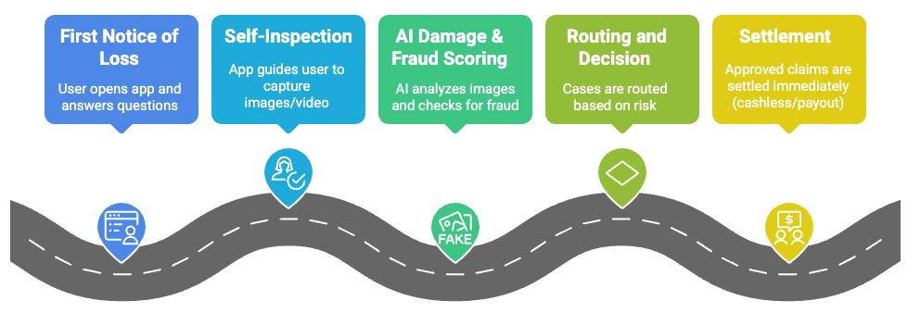
The day-time journey is given to the right. To handle night-time incidents where good photos are impossible, the journey adds a two-step, time-aware flow. First, the app supports “stub” reporting at night: the user records a short description or voice note, shares location and time, and uploads any provisional photos. This locks coverage with a time-stamped claim. Next morning, the app triggers guided self-inspection in daylight, running the usual camera flow and AI checks. Clear messaging and basic validation (location/time, policy status) balance prompt intimation, fraud control, and practical constraints.
3. MVP
- AI-enabled vehicle damage detection
  - Deep-learning models evaluate uploaded photos to decide whether each panel is healthy or damaged and enable multi-panel inspections.
  - This speeds up pre-inspection and helps segment minor claims into clean auto-approvals vs exceptions.
- AI-based parts repair vs replace recommendation
  - For each damaged panel, an AI tool recommends whether to repair or replace, based on eight standard “poses” and historical cost/outcome data.
  - This supports consistent, fast decisions and can also nudge towards greener, more economical repairs where appropriate.
- NLP-based call transcription and intent identification
  - For cases where human calls are still needed (e.g., borderline minor claims), calls are transcribed automatically and key intents/events are extracted.
  - This reduces manual documentation time for claims handlers and ensures that important details are not lost.
- Sentiment-based call summarisation
  - Speech-to-text and sentiment analysis help summarise caller mood and intent, allowing ops teams to prioritise distressed or at-risk customers.
  - Summaries are attached to the claim file so anyone touching the case quickly understands context, reducing repeat calls.
- Self-service and channel breadth
  - Digit reports a large reduction in call volume after revamping digital self-service, with heavy use of app + WhatsApp for KYC updates, policy changes, pre-inspections, and claims.
  - InsureApp’s MVP can mirror this by:
    - Offering the minor-claims journey through app and a chat channel (e.g., WhatsApp-style bot).
    - Letting users track status, upload missing documents, and get clarity on decisions without calling.

